## How to make Grilled Octopus

We are fortunate that we live in the Western Suburbs of Chicago and we have numerous sources for almost any fresh ingredient you could want. One thing our family often craves is my grilled octopus and fresh seafood salads, which are famous in some parts of Chicago. One way to prepare octopus is to boil it until it is tender and then to lightly grill it or put it under the broiler.

You should always tenderize your octopus before cooking it. In Italy the fishermen beat the octopus against the rocks by the ocean before cooking it. Since we use fresh octopus, some say the easiest way to tenderize a fresh octopus is to beat the living daylights out of it with a blunt object, but most octopus sold in the US have been previously frozen. In this case no tenderizing is really necessary, but you can still use your meat tenderizer if you want too.

Many Chefs add a few wine corks to the cooking pot and it is said to tenderize the octopus. We added this step to our recipe, but it is not required.

After your octopus is cooked, just drizzle a light citrus vinaigrette or a little extra virgin olive oil. Our octopus can be eaten as an appetizer or as an entrée (like many of my Seafood Platters) or it can be chopped into pieces as part of a delicious seafood salad.

[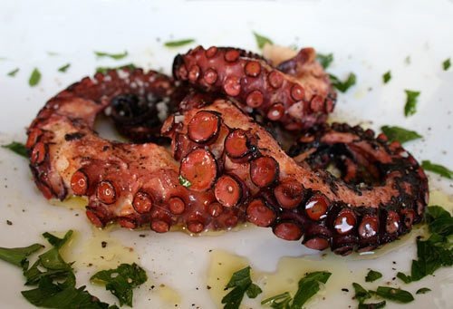](https://italiancountryhouse.files.wordpress.com/2012/03/octopus.jpg)

### Grilled Octopus recipe:

2 Pound Octopus

2 Wine Corks

1 Cup White Wine

1 Lemon, Sliced in half

Extra Virgin Olive Oil

2 Cloves of Minced Garlic

Fresh Chopped Parsley

Sea Salt to taste

Cracked Black Pepper to taste

Put the octopus in a saucepan large enough for it, add half of the lemon, a few wine corks and a cup of white wine. Add just enough water to cover the octopus and then cover with a lid. Heat on your stove on high but once boiling reduce the heat to a simmer. Make sure you cook the bottom of the octopus so it is tender when pierced by a fork. Turn off the burner and than just allow the octopus to cool in the water to room temperature.

Remove the tentacles from the head and if you want, cut the head into pieces as well. Drizzle the octopus pieces with a lightly cover of Olive Oil. You can than heat up the grill or broiler and cook until the edges begin to crisp and brown (be careful not burn). Drizzle on a little more olive oil, squeeze lemon on top, sprinkle with chopped parsley and minced garlic. Then just season with salt and pepper and enjoy.

Buon Appetito!

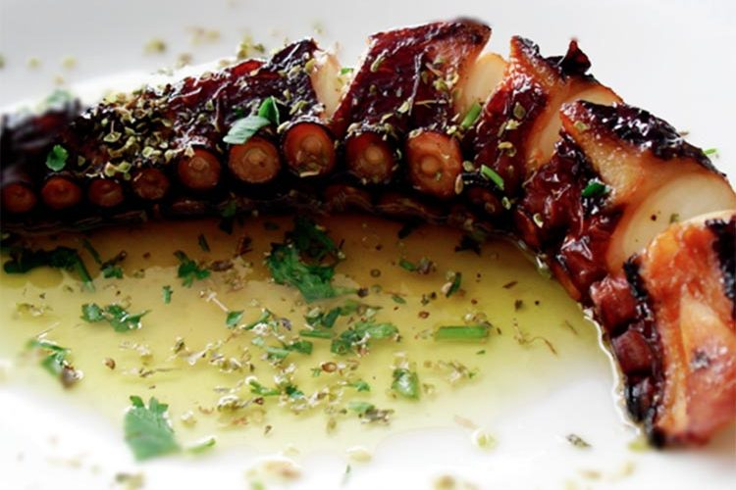Grilled octopus with potato emulsion and olive oil

# GRILLED OCTOPUS WITH POTATO EMULSION AND OLIVE OIL

[**DIARIODEGASTRONOMIA.COM**](http://diariodegastronomia.com/author/diariodegastronomia-com/)**05/15/2017**

The history of the olive tree in Lower Aragon is very similar to that of the entire Mediterranean area, given its proximity and its peculiar climate similar to the Levantine one. Possibly its introducers were the Phoenicians or the Greeks, what is known is that the cultivation did not reach too much importance until the arrival of Scipio as it is deduced from the book of Avienus Ora Marítima, in which the Ebro is called oleum flumen, that is , river of oil.

And today, olive oil is one of the most characteristic products of Bajo Aragón. The Bajo Aragonese olive tree has a familiar name: Empeltre. It is the variety that is grown there. The best olive trees in Spain grow in fresh, deep limestone soils, such as those in the Lower Aragón area.

Olives that produce the exquisite Lower Aragón Olive Oil, the Extra Virgin olive oil from olives whose cultivation, processing, packaging and marketing is carried out in this region. The extraction procedures will be exclusively mechanical. By mechanical procedures we mean grinding, shaking, pressing, centrifuging, decanting and filtering, without the product undergoing any type of transformation that alters its natural characteristics.

The differential characteristics of the Lower Aragón Oil can be defined in three points: appearance (clean, without signs of turbidity or dirt), color (yellow with shades from golden yellow to old gold, characteristic of the Empeltre variety) and flavor (oil soft, fluid and very pleasant on the palate, with flavors reminiscent of the fragrance of the olive tree) An extra virgin olive oil that in the kitchen gives rise to elaborations such as this **Grilled Octopus with potato emulsion and olive oil** , a recipe offered by the Regulatory Council of the [Lower Aragón Oil Denomination of Origin](http://www.aceitedelbajoaragon.es/) .

## Grilled octopus with potato emulsion and olive oil

**INGREDIENTS**

For 4 people

**For the octopus**

* 4 octopus legs
* Extra virgin olive oil
* Lemon

**For the potato and olive oil emulsion**

* ½ kg. of patatos
* Sea salt
* Cumin
* 1/8 l. extra virgin olive oil
* 1 tablespoon of almond oil
* Salt
* Ezpelette peppers
* 1 tablespoon fresh chives

**Also**

* Green or white asparagus

**ELABORATION**

**For the octopus** . Cook the octopus legs and marinate for a few hours in olive oil and lemon. Brown them for a few minutes on the grill.

**For the potato and olive oil emulsion** . Cook the potatoes with sea salt and cumin. Make a puree with the potatoes and the rest of the ingredients.

**Finishing and presentation** . Arrange a base of green or white asparagus, place the octopus on top and surround the potato emulsion and olive oil

# **OCTOPUS A LA PLANCHA AND ITS AROMATICS: IDEAL FOR AN APERITIF!**

 September 26, 2018  [Carla](https://www.marmitedumonde.com/author/carla)

Of Spanish origin, octopus a la plancha is a really tasty tapa (or tapas!) That you can serve ideally at aperitif time. Octopi lovers, consider imperative to try our classic recipes  [Grilled octopus with garlic and olive oil](https://www.marmitedumonde.com/entree/7573/poulpe-grille-ail-huile-olive)  the  [Octopus Italian: delizioso insalate di polpo!](https://www.marmitedumonde.com/entree/8328/poulpe-a-litalienne-insalate-di-polpo)without forgetting the  [Octopus in tomato sauce](https://www.marmitedumonde.com/plat/8464/poulpe-sauce-tomate) .

[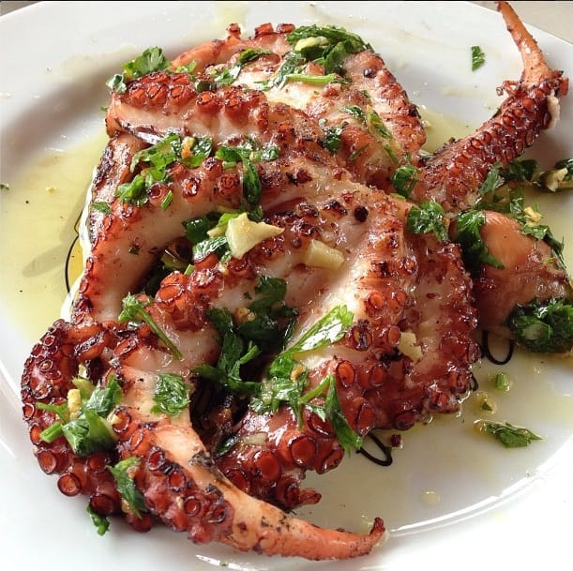](https://www.marmitedumonde.com/wp-content/uploads/2018/09/Poulpe-a-la-plancha-recette.jpg)

## Octopus a la plancha: the ingredients

For 4 people:  
- 1.5 kilograms of fresh octopus  
- 4 lemons  
- 2 new onions  
- 2 cloves of garlic  
- 20 cl of wine vinegar  
- 10 cl of dry white wine  
- A little olive oil  
- A few Sprigs of Oregano  
- A few sprigs of rosemary  
- A few sprigs of thyme  
- Salt and pepper

## Octopus a la plancha: the recipe

- Wash the octopus in clear water and dry it well  
- Prepare the marinade by placing the octopus in a large saucepan and covering it with olive oil  
- Pour the white wine over the octopus  
- Add a few sprigs of thyme and rosemary  
- Cover the whole with water and cook the octopus in its marinade over high heat for two hours  
- Place a fork in the octopus after two hours. If it is cooked, the blade must be able to enter without any resistance  
- Take the octopus out of the water, drain it and cut it into small pieces  
- Reserve in a salad bowl  
- Mix two tablespoons of olive oil with the wine vinegar in a bowl  
- Add the juice of two lemons  
- Finely slice the onions and chop the garlic cloves then add them to the preparation  
- Season with a little oregano, salt and pepper to your liking  
- Let the octopus pieces marinate for at least one hour in a cool place  
- Brown the pieces on [an electric plancha](https://amzn.to/2N2B5Zi) that you have previously heated for 20 minutes  
- Serve the grilled pieces with lemon juice and a little olive oil.

# **GRILLED OCTOPUS WITH GARLIC AND OLIVE OIL**

 June 22, 2017  [Carla](https://www.marmitedumonde.com/author/carla)

Octopus is one of the tastiest foods of the Mediterranean gastronomic heritage. It gives rise to sunny recipes made to be shared in a friendly atmosphere. Our recipe for grilled octopus with garlic and olive oil is the perfect illustration of this. If you like it, then you will also like our  [Portuguese Octopus Salad (Salada de polvo)](https://www.marmitedumonde.com/recettes/610/salade-de-poulpe-portugaise) .

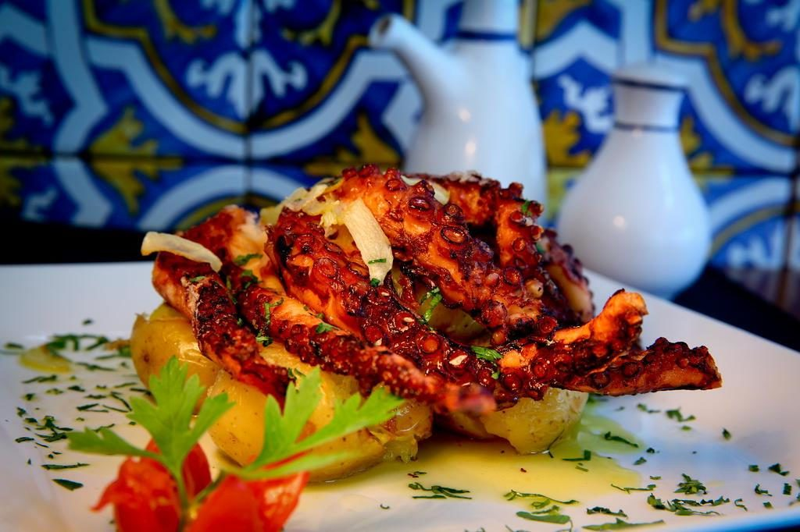

## Grilled octopus: the ingredients

For 4 people :

* 1 whole octopus emptied between 500 grams and 1 kilogram
* 2 cloves garlic
* 2 onions
* 2 bay leaves
* 1 bouquet garni
* 1 sprig of thyme
* 5 untreated yellow lemons
* 2 untreated limes
* Espelette pepper
* Oregano
* Olive oil
* Salt and pepper

## Grilled octopus: the recipe

* Rinse the octopus under cold water and wipe it dry.
* Hit the octopus against a work surface, on all sides, for 5 minutes, to soften it.
* Peel and mince the onions.
* Wash and cut the lemons in half
* Pour 1 liter of water into a [large saucepan](http://amzn.to/2tRjGcW) , and put the bay leaf, onions, bouquet garni, yellow lemons and 20 centilitres of white wine.
* Season with salt and pepper and bring to a boil.
* Immerse the octopus in water and cook over medium heat and cover for 45 minutes.
* When the octopus is cooked, drain it and place it in a bowl of cold water.
* Peel and chop the garlic.
* Take the zest and juice from the limes.
* Remove the leaves from the thyme.
* In a bowl, put 10 centiliters of olive oil.
* Add the garlic, thyme, 1 tablespoon of oregano, the juice and zest of the lemons.
* Season with salt and pepper and sprinkle with Espelette pepper.
* Separate the tentacles from the octopus head and cut out the tentacles.
* Brush the octopus with olive oil, using a brush, and place it in a deep dish.
* Drizzle the octopus with the rest of the marinade.
* Cover with cling film and refrigerate for 30 minutes.
* Take the octopus out 15 minutes before grilling it.
* Start the barbecue or preheat the plancha.
* Drain the octopus and grill the tentacles and pouch on all sides for 1 to 2 minutes.

Tip: serve your grilled octopus in garlic and olive oil with a potato salad seasoned with a vinaigrette with fresh herbs and lemon, and accompany with a rosé wine (Côtes de Provence or Baux of Provence).

# **PORTUGUESE OCTOPUS SALAD (SALADA DE POLVO)**

 June 26, 2016  [Carla](https://www.marmitedumonde.com/author/carla)

Our Portuguese Octopus Salad Recipe is a delicious dish that can be enjoyed at any time of the day. Octopus is very popular in Portugal. It is eaten just as well as an aperitif, as a starter, salad or main course. It is a la carte in most restaurants and "bistros". The [octopus](https://fr.wikipedia.org/wiki/Pieuvre) is very difficult to cook. So, we are going to give you our tip for successful cooking, so that you can enjoy this wonder in the mouth! If you don't have enough time and you want to do it on a whim, then buy frozen octopus in Portuguese grocery stores, specialist frozen food stores or even in the dedicated shelves of hypermarkets.

[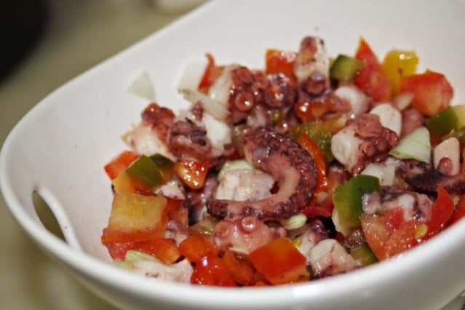](https://www.marmitedumonde.com/wp-content/uploads/2016/06/salade-de-poulpe-poivrons-portugaise.jpg)

## Portuguese octopus salad: the ingredients

* 1.5 kilograms of octopus
* 2 onions
* 3 cloves of garlic
* 1 bay leaf
* 1 red pepper
* 1 green pepper
* 1 deciliter of olive oil
* 2 tablespoons of wine vinegar or shallot
* 1 lemon
* 1 bunch of coriander
* 1 chilli (optional)
* Coarse salt
* Salt and pepper

## Portuguese octopus salad: the recipe

* Rub the fresh octopus with coarse salt to remove the loose nerve tissue with ease.
* Remove the eyes and all bags from the head (possibly ask the fishmonger to do it for you).
* Cut the small ends of the tentacles to allow the cooking water to circulate.
* Wash and freeze the octopus for a few hours (preferably the day before).
* To put of the'water in pressure cooker and make cook the octopus (still frozen) about 35 to 40 minutes with a onion no peeled, the Bay leaf as well as the chilli pepper (the latter is not recommended if you have  children at table…).
* Cook the peppers at 220 oven degrees up to 'that his skin become black.
* Remove the skin from the peppers. Trick : put the peppers in a plastic bag good closed And let cool. The skin will be removed almost fromshe-even.
* Remove the octopus from the casserole -minute , the cut in small ends and the dispose in one bowl . Water with thejuice of lemon.
* Cut the peppers and put them with the octopus.
* Peel the other onion and thegarlicand chop very finely. Add to the octopus.
* Season withoil olive, the vinegar , the salt and the pepper then mix the all.
* Chop the coriander and sprinkle the dish with elegance.